**2023**

**Year 12 Earth and Environmental Science – Unit 4**

**Task 8: Natural Disasters and ENSO Test**

**Weighting: 9%**

**Duration: 45 minutes**

**Name: _______________________**

**Date: _____________________**

|  |  |
| --- | --- |
| **Section 1: Multi-choice** |  |
| **Section 2: Short Answer** |  |
| **Total Mark** |  |

*I acknowledge that all the information contained in this task is my own work and not taken from other sources. If other sources have been used they have been acknowledged in my references.*

____________________________________

(Student Signature)

*Please see SEQTA for teacher feedback and comments.*

**SECTION 1: MULTI-CHOICE:**

*Please circle the correct answer in the below questions.*

1. What is the primary cause of earthquakes?
   1. Shifts in oceanic plates
   2. Intense volcanic activity
   3. Atmospheric pressure changes
   4. Tectonic plate movements
2. Which of the following is a characteristic of a tsunami?
   1. Ground shaking and tremors
   2. Rising and falling of sea levels
   3. Sudden release of volcanic gases
   4. Rapid temperature changes in coastal areas
3. What does the acronym ENSO stand for?
   1. Environmental Natural Science Organization
   2. Earthquake and Natural Safety Operations
   3. El Niño-Southern Oscillation
   4. Enhanced Nautical Seismic Observations
4. Which of the following is NOT a phase of ENSO?
   1. El Niño
   2. La Niña
   3. Southern Oscillation
   4. Neutral
5. Which of the following is a commonly used scale for measuring the magnitude of earthquakes?
   1. Richter scale
   2. Beaufort scale
   3. Fujita scale
   4. Saffir-Simpson scale
6. What is the major factor that contributes to the formation of El Niño events?
   1. High levels of air pollution
   2. Changes in ocean currents
   3. Solar flares and sunspots
   4. Lunar gravitational pull
7. Where are earthquakes most likely to occur?
   1. Nepal
   2. In the magma
   3. Tectonic plate boundaries
   4. Anywhere in the world

**SECTION 2: SHORT ANSWER**

1. Describe what an earthquake is and how they occur. (3 marks)

______________________________________________________________________________________________________________________________________________________________________________________________________________________________________________________________________________________________________________________________________________________________________________________________________________________________________________________________________________________________________

1. Label the following diagram of an earthquake. A word bank has been supplied for you. (5 marks)

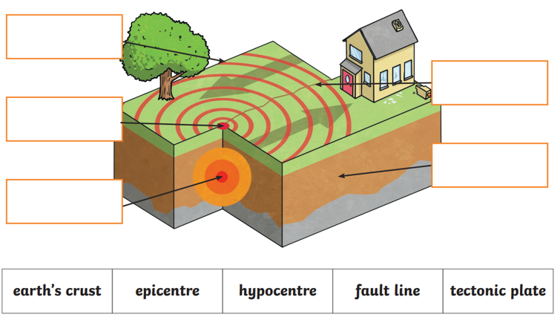

1. Explain what the magnitude of an Earthquake means (2 marks)

____________________________________________________________________________________________________________________________________________________________________________________________________________________________________________________________________________________________________________________________________

1. Describe what a tsunami is and explain how they occur. (3 marks)

______________________________________________________________________________________________________________________________________________________________________________________________________________________________________________________________________________________________________________________________________________________________________________________________________________________________________________________________________________________________________

1. Describe one method of minimising the damage caused by Earthquakes or Tsunamis. (2 marks)

____________________________________________________________________________________________________________________________________________________________________________________________________________________________________________________________________________________________________________________________________

1. Attempt to explain the fact that Australia experiences a relatively low number of earthquakes compared to our neighbouring country, New Zealand. (2 marks)

____________________________________________________________________________________________________________________________________________________________________________________________________________________________________________________________________________________________________________________________________

The El Nino Oscillation (ENSO) has a significant impact on climate conditions to the East coast of Australia as well as other regions throughout the Pacific Ocean.

1. Explain the three phases of ENSO.

Normal phase: (3 marks)

_____________________________________________________________________________________________________________________________________________________________________________________________________________________________________________________________________________________________________________________________________________________________________________________________________________________

El Nino: (3 marks)

_____________________________________________________________________________________________________________________________________________________________________________________________________________________________________________________________________________________________________________________________________________________________________________________________________________________

La Nina: (3 marks)

_____________________________________________________________________________________________________________________________________________________________________________________________________________________________________________________________________________________________________________________________________________________________________________________________________________________

1. Describe what weather conditions Australia experiences during an El Nino phase. (2 marks)

____________________________________________________________________________________________________________________________________________________________________________________________________________________________________________________________________________________________________________________________________

**END OF ASSESSMENT**